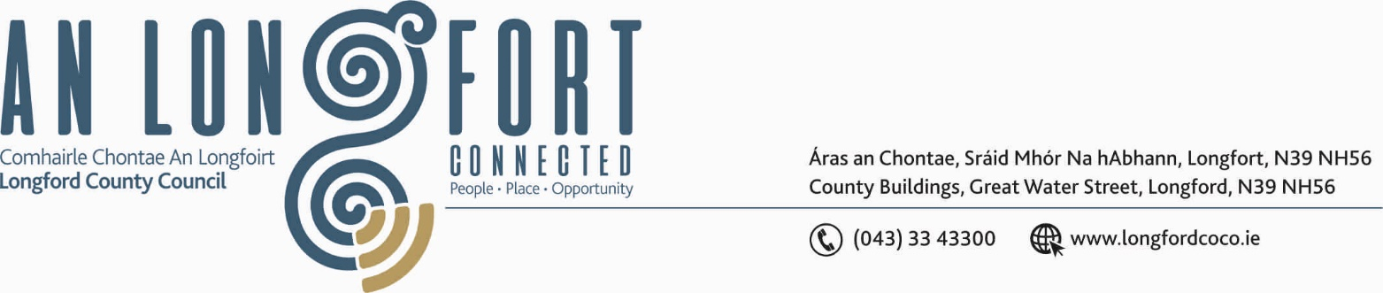

GRANARD MUNICIPAL DISTRICT

Corporate Affairs,
Aras an Chontae,
LONGFOIRT.

21st November 2018.

To: Each Member of Granard Municipal District.

Dear Member,

You are requested to attend Meeting of Granard Municipal District to be held in
Granard Community Library on Tuesday, 27th November 2018 at 3.30 p.m. to transact business, as set out on the Agenda hereunder.
5.00 p.m.
Opening of an Exhibition celebrating Longford Women in Public Life over the past 150 years and presentation to Granard Library of a painting on Michael Collins by local artist, Eilish Creamer.

Yours sincerely,
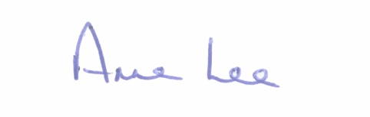

_______________
Anne Lee,
Meetings Administrator.

AGENDA

Prayer before meeting.

1. Confirmation of the Minutes of Granard Municipal District Meetings held on the 25th September and 8th November 2018 – copy enclosed.

2. Matters arising from Minutes.

3. Area Engineer’s Progress Report.

4. Primary School’s Digital Project.

5. Consideration of Adoption of Part 8 Report (Planning and Development
Regulations 2001) (as amended) in respect of proposal to construct
6 x 2 Bed Single Storey Dwellings at Ballinalee or St. Johnstown, Ballinalee,
Co. Longford - details attached.

6. Recommendation from Placenames Sub-Committee regarding the official
naming of Murphy’s Cross.

7. Notices of Motions submitted by Councillors, as listed hereunder. –

Councillor Michael Carrigy.

“I call on the Minister for Rural and Community Development to amend the criteria for the Local Improvement Scheme to allow for roads with one landowner to be eligible.”

Councillor P.J. Reilly.

“That Speed Driver Feedback Signs be installed on the N55 on the approach road in Granard from Cavan and also on the R396 on the approach road in the Village of Abbeylara from Coole. Co. Westmeath.”

8. Correspondence – circulated.
(i) Letter dated 10th October 2018 received from
Minister Kevin Moran, T.D., regarding the Bommergang Hickstead Trophy.

::::::::::::::::::::::::::::::::::::

